**1). Write a C program to find that the accepted number is Negative, or Positive or Zero.**

**CODE 1 :**

/*Write a C program to find that the accepted number is Negative, or Positive or Zero.*/

#include <stdio.h>

int main()

{

int a;

printf("Enter the Number : ");

scanf("%d", &a);

If (a < 0)

printf("Entered number is Negative.");

else if (a > 0)

printf("Entered number is positive.");

else if (a == 0)

printf("Entered number is zero.");

return 0;

}

**OUTPUT 1 :**

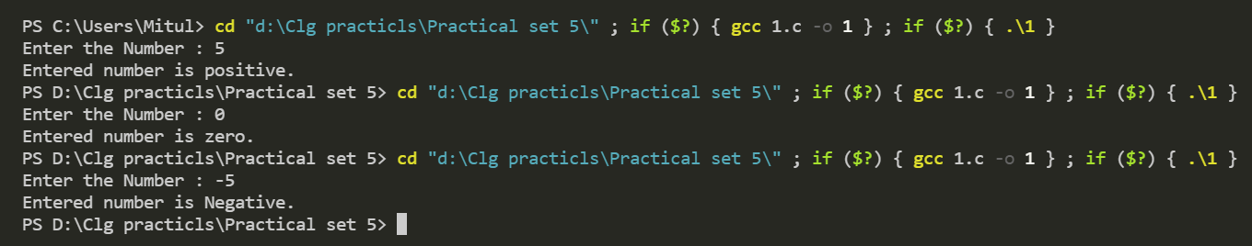

**2). Write a program to read three numbers from keyboard and find out maximum out of these three. (nested if else).**

**CODE 2 :**

/*Write a program to read three numbers from keyboard and find out maximum out of these

three. (nested if else) */

#include<stdio.h>

int main()

{

int a, b, c, max=0;

printf("Enter The First Number : ");

scanf("%d", &a);

printf("Enter The Second Number : ");

scanf("%d", &b);

printf("Enter The Third Number : ");

scanf("%d", &c);

If (a>max)

{

max=a;

if (b>max)

{

max=b;

if (c>max)

{

max=c;

}

}

}

printf("The Maximum Out Of Entered Three Numbers Is %d", max);

return 0;

}

**OUTPUT 2 :**

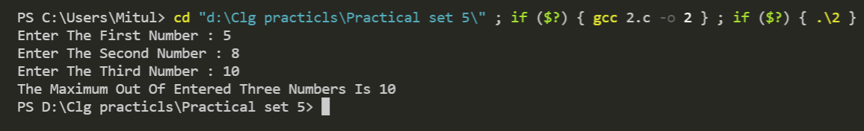

**3) Write a C program to check whether the entered character is capital, small letter, digit or any special character.**

**CODE 3 :**

/*Write a C program to check whether the entered character is

capital, small letter, digit or any special character.*/

#include <stdio.h>

int main()

{

char ch;

printf("Enter Any Character : ");

scanf("%c", &ch);

If (ch >= 'a' && ch <= 'z')

{

printf("The Entered Character Is In Small Letter");

}

else if (ch >= 'A' && ch <= 'Z')

{

printf("The Entered Character Is In Capital Letter");

}

else

{

printf("The Entered Character Is Special Character");

}

return 0;

}

**OUTPUT 3 :**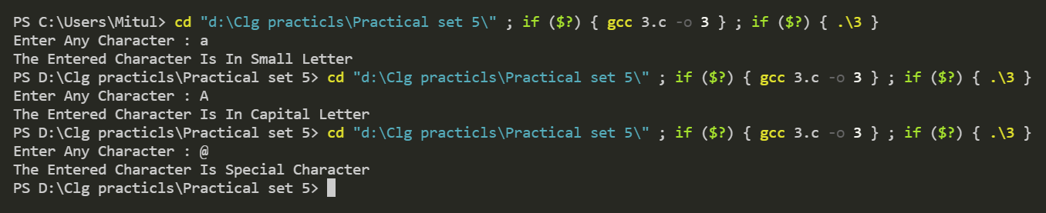

**4). Write a program to read marks from keyboard and your program should display equivalent grade according to following table(if else ladder)**

**Marks Grade : 100 - 80 Distinction 79 - 60 First Class 59 - 40 Second Class < 40 Fail**

**CODE 4 :**

/*Write a program to read marks from keyboard and your program should display equivalent grade

according to following table(if else ladder)

Marks Grade : 100 - 80 Distinction

79 - 60 First Class

59 - 40 Second Class

< 40 Fail */

#include <stdio.h>

int main()

{

int a;

printf("Enter the marks out of 100 : ");

scanf("%d", &a);

if (a > 100 || a < 0)

printf("Please enter valid marks.");

else if (a >= 80 && a <= 100)

printf("You are pass with Distinction.");

else if (a >= 60 && a <= 79)

printf("You are pass with First Class.");

else if (a >= 40 && a <= 59)

printf("You are pass with Second Class.");

else if (a < 40)

printf("You are Fail.");

return 0;

}

**OUTPUT 4 :**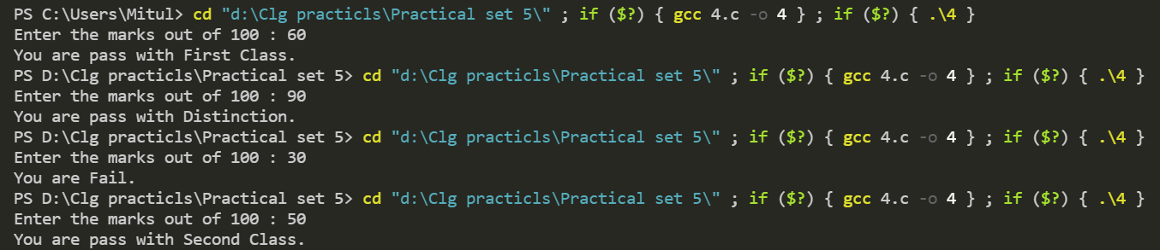

**5). Write a c program to prepare pay slip using following data. Da = 10% of basic, Hra = 7.50% of basic, Ma = 300, Pf = 12.50% of basic, Gross = basic + Da + Hra + Ma, Nt = Gross – Pf.**

**CODE 5 :**

/*Write a c program to prepare pay slip using following data. Da = 10% of basic, Hra = 7.50% of

basic, Ma = 300, Pf = 12.50% of basic, Gross = basic + Da + Hra + Ma, Nt = Gross – Pf. */

#include <stdio.h>

int main()

{

float basic;

printf("\n Enter Basic Salary :");

scanf("%f", &basic);

printf("===================================");

printf("\n SALARY SLIP");

printf("\n===================================");

printf("\n Basic : %.2f", basic);

printf("\n DA : %.2f", basic * 0.10);

printf("\n HRA : %.2f", basic * 0.075);

printf("\n MA : %.2f", 300.00);

printf("\n===================================");

printf("\n GROSS : %.2f", basic + (basic * 0.10) + (basic * 0.075) + 300.00);

printf("\n===================================");

printf("\n PF : %.2f", basic * 0.125);

printf("\n===================================");

printf("\n NET : %.2f", (basic + (basic * 0.10) + (basic * 0.075) + 300.00) - (basic * 0.125));

printf("\n===================================");

return 0;

}

**OUTPUT 5 :**